* Section slides: <http://webdev.slides.com/coltsteele/mysql-105#/>
* In this section, we’re going to see how to connect MySQL to another language, in this case node.js.
* We will connect a JavaScript file and connect it to a MySQL database

# MySQL and Other Languages

* So far we’ve been working with MySQL on its own. Now we’re going to lay the foundations for creating web applications with MySQL
  + We’ll learn how to get an external language to talk to MySQL
* We’ve been working with our CLI to ask questions of our data using MySQL, and that is a very common and important use of MySQL
* But now it’s time for this:
  + All of these languages have ways of communicating with MySQL

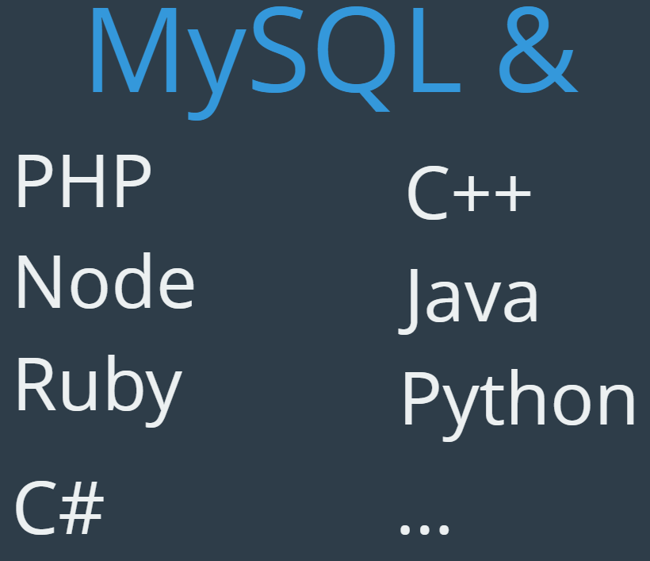

* + In this class we will work with Node, which is a JavaScript runtime environment that can execute JavaScript code outside of a web browser
    - https://en.wikipedia.org/wiki/Node.js
  + We could have gone with PHP, as it’s historically been closely associated with MySQL. The next lecture will talk about what might be going on with PHP
  + So, how do we talk to MySQL through external code, and what would it do? Check out this schematic
    - A client’s computer (via a web app) makes a request to NodeJS (a website’s stack).
    - Then the stack (e.g. Node) will talk to the MySQL database, creating a query depending on what the client wants
    - Node then will return the queried items to NodeJS (or whatever language), which will then compile the result, build a response (e.g. a webpage), and shoots it back to the client

